KBEP

(Kech Business Enhancement Platform)

A final year project submitted to

**Department of Computer Science**

**University of Turbat**

In partial fulfilment of the requirement of the degree

**Master of Computer Science**

**(MCS)**

**Submitted By:**

1. **ABDUL LATIF**
2. **ALLAH BAKHSH**
3. **MEHRAB AZUM**
4. **SANA ULLAH**
5. **ADAM JAN**
6. **AHMED SHAH**





**CERTIFICATE**

This is certified that the work presented in this project report on “**Kech Business Enhancement Platform**” is entirely written by them under the supervision of

**Mr.Junaid Qadir** web developer, University of Turbat (**UOT**)

**GROUP MEMBERS**

Abdul Latif

Allah Bakhsh

Mehrab Azum

Adam Jan

Sana Ullah

Ahmed Shah

**Advisor**

Junaid Qadir

Computer Science Department University of Turbat

**Chairman**

Mukhtar Hussain

Department of Computer Science University of Turbat

**ACKNOWLEDGMENT**

In the name of Allah, the most merciful and the most supreme, praises are for him, whom without it could not be possible for us to complete our final year project with its documentation. The journey we started was very tough for us at initial stage but we always remembered that Allah, the most gracious, will give us courage to seek success.

In every field of success there always remains some motivators, guiders, supporters who never let his team behind and to be distorted. Same like in our journey we met with a lot of faces who helped us to become something and guided us to never lose hope in achievement of your target. Especially appreciable thanks to **Sir Mukhtar Hussain,** **Sir Balach Bali, Sir Junaid Qadir, Sir Mamoon, Sir Bilal ur Rehman, Miss Parinaz, Miss Shamsa Aziz.**

We would like to express our deep gratitude to all of them for giving us quality education and always remain with us. The success and the final outcome for this project required a lot of guidance and we are extremely thankful to all of them mentioned above for supporting and guiding us to accomplish such a successive dream.

We are especially thankful to our parents without their prayers we could seek such a glance activity of achieving a successful task.

**Abstract**

Turbat has become the most expensive city of Balochistan, and well famous for businesses. In this new era every business must have a source to promote his business.

KBEP (Kech Business Enhancement Platform) is developed as a promoting website to enhance business activities of Kech and as well as a directory of Kech for the people to find their right businesses. KBEP provides all types of businesses descriptions such as electronic shops, general stores, barber shops, car workshops, medical stores, garments shops, clothes, sport shops, and other small and large businesses.

And another additional feature included in KBEP is the star rating review with comments about businesses. In every business KBEP will also promote members working in a business, such as work shop mechanics, car service cleaners, general store workers and other businesses. KBEP is mainly target toward people of Kech to find right business. KBEP enables visitors to checkout businesses on the bases of high star ratings.

Table of Contents

**Chapter No: 1………………………………………………………………………………………...**6

1.1 Introduction…………………………………………………………………………………………………………………….…6

1.2 Motivation………………………………………………………………………………………………………………………….6

1.3 Aims and observation…………………………………………………………………………………………………………7

1.4 Process Model……………………………………………………………………………………………………………………7

1.5

**Chapter 2** 9

# **Chapter No: 1**

* 1. Introduction

The project “KBEP” (Kech Business Enhancement Platform) is introduced to promote businesses of Kech as a directory based website. KBEP contains all information of businesses description of Kech with map location such as Electronic shops, book retailers, barber, car workshops, service shops, tailors, medical stores, garments, general store and other small and large businesses will be promoted in KBEP on the bases of star reviews and comments.

Development of KBEP the tool required for the platform is HTML, CSS, JavaScript, MySQL and the framework of Microsoft (.Net core). MySQL will be used to store the information of businesses as database. The platform has a control panel for administrator that can add, delete, update, and maintain information. To make the platform attractive CSS (bootstrap) and JavaScript is used to maintain the platform activities. Business will be promoted on the bases of rating star and comments.

* 1. Motivation

KBEP is best for promoting businesses. Once can add his business in this platform and customer will view it to visit the business which might not be seen in another aspect. KBEP is designed for both the businessman to promote their businesses in a platform and customer to visit the best business through rating star and comments. Customer can easily get things without wasting much time. For example a customer wants to repair his car and needs sphere part. By visiting all shops he can waste much of his time and may not get best sphere part of the car. KBEP will mainly focus with such type of situations to find things in a business without wasting a lot of time to get things even in minutes. The customer can simply just have a visit to KBEP and can find which shop has the highest rating star for sphere parts. In other aspects this platform will enhance business activities.

* 1. Aims and objectives:

Our aim for this project is to enhance local business dealings by making them discoverable by masses. KBEP is a profile based platform for local businesses which is designed for enhancing business activities on a web based platform. KBEP in other aspect is a directory based website where businesses information’s are stored. Another feature it includes is designed for visitors of KBEP, is the star rating of businesses. In this platform business information is stored such as where shop is located, who is the owner of the shop, contact information and as well as map of the shop is attached.

Information of all types of businesses is added customer can visit and check out.

* 1. process model:

Process model defines the functionality of the software how it is being developed.

Process model can help developing the software according to the environment and nature of the software.

* 1. Incremental model:

Reasons for selecting incremental process model, is the method of developing software through models by implementing and testing incrementally (Incomplete objects are added each time incrementally) until the software is developed.

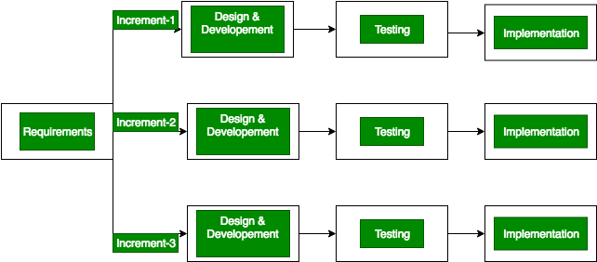

Figure 1.1 Incremental Process Model

* 1. Overview

KBEP has been designed to enhance activities in Kech. Following features will describe a brief overview of the platform.

* Business profiles for better promoting helping business to be discoverable.
* Business listing of small businesses in turbat city with details about the business.
* Details of experts working in different areas of the businesses.
* Visibility for skilled workers in Turbat city.
* Help people of turbat and visitors to find skilled and lesser known workers or experts easily which would have been difficult otherwise.
* Enhance business activities and generate more revenue for them.

# **Chapter 2**

2.1 About system:

The proposed system is a business enhancement platform for local businesses and a directory of shops in kech. KBEP shares information of businesses available in turbat city, such as location of shops, availability of product, owner and contact information. For developing such a creative platform, information is collected from different sources such as visiting shops of kech, asking people about different businesses and famous workers having skills in different aspects of businesses. Following features will define the overall system.

Promotion of business through masses.

Business profiles for better promoting helping business to be discoverable.

Business listing of small businesses in turbat city with details about the business.

Details of experts working in different areas of the businesses.

Visibility for skilled workers in Turbat city.

Help people of turbat and visitors to find skilled and lesser known workers or experts easily which would have been difficult otherwise.

2.2 Role of Admin:

The interface designed foradmin have a login panel for authorization. The admin panel is actually the authenticated person to manage the platform in which the content of the software is edited by him. For example add businesses information, delete business information, update business info, manage platform.

2.3 Role of User:

KBEP is open for all users to visit and search businesses information and specifications. They can creat individual user id for their shops, search different types of business shops, car workshops, electric shops, barber, tailors, clothes, bakery shops, general shops and other small and large business shops.

The users also can provide feedbacks and rate the shops through rating stars after visiting business.

2.4 Development Technologies:

The platform is a web based application and following are the technologies used for development of platform.

* HTML 5
* CSS(Bootstrap)
* JavaScript
* ASP.net MVC
* Microsoft Framework(.Net core)

2.5 Hardware Requirements:

* **Processor**: Intel Dual core 1.7Ghz or Higher
* **RAM:** 2GB or above for better performance
* **Hard:** Disk: 40GB

2.6 Software Requirements:

* Operating system windows 7/8/10
* IE, Google Chrome
* DNS server

2.7 Requirement Specification

Requirements have collected from different sources such as collecting information from shops, user perspectives.

2.7.1 Functional Requirements:

Functional requirements are the activities system performs.

Following are the functional requirements system perform for admin:

**Login:**  There login system or panel where admin can login to perform operations.

**Update or Modify:** Administrator can update or modify existing information.

**Insert New Information:** Administrator can insert new information.

**Delete Information:** Admin using admin panel can delete information.

**Change platform setting:** In admin panel all setting of site can be changed including mail id, main page, and slide bar, contact, about us.

**Logout:** Admin or member end session using logout.

**Submit feedback:** A textbox will be available for visitor/users to send feedback.

**Rate shops:** Star rating review is used to rate businesses.

### **2.7.2 Non-Functional Requirements:**

Non-functional requirement defines how the system performs activities. Following are the non-functional requirements system performs.

**Efficiency:**

System must be able to provide fast access for adding information’s for admin while data entry or updating settings.

**Reliability:**

Reliability depends on the bases of system response and accuracy.

**Security:**

System must be secure from unauthorized access. Preferences should only be allowed for admin**.**

2.8 User Interface:

The concern of user interface is to focus on how easily the system responds and act upon the user request.

Hardware interface:

The hardware interface does not require any additional type of specification. It can be used in any computer such as laptop or personal computer and also fit in mobile or tablets.

Software interface:

This platform can be run using any version of Microsoft windows operating system with the help of a server, with the help of a browser (internet explorer, Mozilla Firefox, Google chrome, Microsoft edge) etc.

# 2.9 Use Cases:

Use cases are the behaviour of software in Unified Modelling Language. A concept in which the behaviour of software is represented for example what type of action user performs and what type of events the system performs. Functionality of the system is represented through actors and use cases. In this platform following are the use cases can be performed by the system.

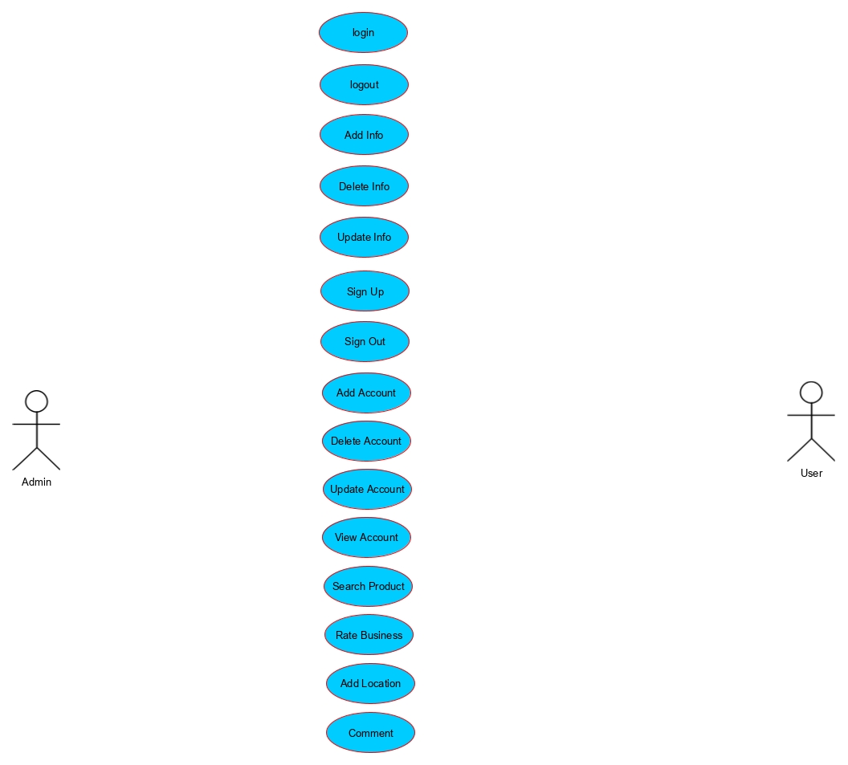

2.10 Use cases Description

The use case description is a written account of the sequence of steps performed by an analyst to accomplish a complete business transaction. It's initiated by an actor, provides value to that actor, and is a goal of the actor working in that system.

**Use case descriptions of KBEP**

2.10.1 Login

|  |  |  |
| --- | --- | --- |
| Use Case ID | 01 | |
| Use Case Name | Admin Login | |
| Actor | Admin | |
| Description | Only authorized person can access. This use case is only for the purpose of securing the content of platform for unauthorized person. | |
| Pre-Condition | Default account must be created for admin authorization. | |
| Post-Condition | Success login | |
| Event Flow | **Actor Action** | **System Response** |
| 1. Click on Admin login in main page.  2. Provide user id and password. | 2. Prompt User ID and password.  3. After success full login redirect to admin panel |
| Alternates | 1. Encase of wrong ID or Password  3.Forget Password | 2. Warning Message  4. Request to reset |

|  |  |  |
| --- | --- | --- |
| Use Case ID | 02 | |
| Use Case Name | Logout | |
| Actor | Admin | |
| Description | This use case redirects to main login page and disconnect admin from the session of login. | |
| Pre-Condition | Admin should be logged in with authenticated User Id and password. | |
| Post-Condition | Returns back to login page. | |
| Event Flow | **Actor Action** | **System Response** |
| 1. Clicks on logout button. | 2. System disconnects session and redirect to login page. |
| Alternates | When close application using task manager or Alt+F4. | The session must be ended automatically |

2.10.2 Logout

2.10.3 Add Information’s

|  |  |  |
| --- | --- | --- |
| Use Case ID | 03 | |
| Use Case Name | Add Information | |
| Actor | Admin | |
| Description | This use case is for inserting business information. | |
| Pre-Condition | Admin must be logged in for inserting information. | |
| Post-Condition | A page with desired given content with be created. | |
| Event Flow | **Actor Action** | **System Response** |
| 1. Click on insert.   3. Fill and click insert. | 1. List of menu opens.   4. information inserted |
| Alternates |  |  |

2.10.4 Delete Info

|  |  |  |
| --- | --- | --- |
| Use Case ID | 04 | |
| Use Case Name | Delete information | |
| Actor | Admin | |
| Description | This allow admin to delete details. | |
| Pre-Condition | Page of businesses details on list must exist. | |
| Post-Condition | The Page must be deleted from site with content and menu. | |
| Event Flow | **Actor Action** | **System Response** |
| 1. Click on desired content name from list and click on delete button. | 1. Site must delete from list with its content and menu. |
| Alternates |  |  |

2.10.5 update/modify info

|  |  |  |
| --- | --- | --- |
| Use Case ID | 05 | |
| Use Case Name | Update Information | |
| Actor | Admin | |
| Description | This use case is to modify/update inserted contents. | |
| Pre-Condition | The webpage must exist at list menu. | |
| Post-Condition | Content must change on site as well as database. | |
| Event Flow | **Actor Action** | **System Response** |
| 1. Click on desired content name. Select web page from list and click on update button.   3. Change as required field and click on update. | 1. Form with desired data appeared.   4. Site updated as with Database. |
| Alternates |  |  |

|  |  |  |
| --- | --- | --- |
| Use Case ID | 06 | |
| Use Case Name | Sign up | |
| Actor | User | |
| Description | This option allow user to create an individual account for his business. | |
| Pre-Condition | A button for sign up must be created. | |
| Post-Condition | Form with required field open after submit, new individual account is created in database. | |
| Event Flow | **Actor Action** | **System Response** |
| 1. Click on sign up button   3. Fill the form and click  Submit. | 2. Form with required content and field is opened.  4. New account is created in database. |
| Alternates |  |  |

|  |  |  |
| --- | --- | --- |
| Use Case ID | 07 | |
| Use Case Name | Sign out | |
| Actor | User | |
| Description | This option allow user to redirect on home page. | |
| Pre-Condition | A button must be created for sign out to end the session of login. | |
| Post-Condition | User is signed out and redirected to login page. | |
| Event Flow | **Actor Action** | **System Response** |
| 1. Click on sign out button. | 2. System ends the sessions of login. |
| Alternates |  |  |